**Empirical Test of Post Earning Announcement Drift (PEAD) in China’s A-share markets: 2015-2022**

**Introduction**

This study examines the profitability of trading on earnings surprises in the post-earnings-announcement period in the Chinese stock market from 2015 to 2020. We find that a post-earnings announcement drift (PEAD) anomaly exists in China. When earnings surprise is defined relative to time-series model forecasts, a hedge strategy of going long the top quintile of earnings surprise stocks and short the bottom quintile of earnings surprise stocks can generate around 4% excess return in 120 days following the earnings announcements.

We find that firms with large positive (negative) earnings surprises exhibit significant positive (negative) abnormal returns up to at least 120 days subsequent to the earnings announcements. There is strong evidence that the price-earnings relation in the post-earnings-announcement period is more eminent when arbitrage risk, as proxied by the idiosyncratic volatility of stock returns, is high or when an earnings surprise is negative. We interpret these findings as impediments to arbitrage activities and the lack of short-selling activities in the Chinese equity markets partially driving post-earnings-announcement abnormal returns.

The seminal study by Bernard and Thomas document that after earnings are announced, cumulative abnormal returns continue to drift upward for positive earnings surprises, and downward for negative earnings surprises. The post-earnings-announcement drift (hereafter PEAD or drift), also commonly referred to as the standardized unexpected earnings (SUE) effect, appears to be a persistent feature of stock returns, at least pertaining to evidence from the United States security markets. It offers three proposals for explanation of PEAD:

(1) the drifts an artifact of methodological shortcomings in the research studies that document the phenomenon

(2) there is an increase in the risk of companies experiencing extreme earnings surprises and the drift represents fair compensation for higher expected return in equilibrium

(3) investors under-react to value relevant information from earnings announcements or they process the information with a significant delay

We address this deficiency by examining the performance of security returns following earnings announcements in China, one of the most exciting major Asia-Pacific security markets. Such an examination is belatedly warranted as financial research is increasingly directed towards the burgeoning markets of China. China has become one of the fastest growing economies and capital markets in the world In terms of the importance of the capital market to the economy, China's capital market is more important than many European countries. The sheer size and enormous growth opportunities of the Chinese security markets have grabbed significant attention and participation from international investors in recent years. In addition, the gradual opening of the Chinese capital markets to international investors also results in a significant share of the Chinese economy being held by global portfolio managers. Compared with the United States, China's capital market has more particularities. China's capital market lacks a relatively large number of short-selling means, and private investors have more abundant capital holdings. These two points may have a more obvious effect on the PEAD anomaly in China. The highlighted significance of the Chinese capital markets therefore increasingly calls for thorough examinations of the informational efficiency in these markets, which is the focus of PEAD research in China.

**Method**

**2.1 Earning surprise**

An earnings surprise, or unexpected earnings, is the difference between the reported earnings and the expected earnings of an entity. Measures of a firm's expected earnings, in turn, include analysts' forecasts of the firm's profit and mathematical models of expected earnings based on the earnings of previous accounting periods. Earnings surprises can be measured using historical earnings or analysts' forecasts. In this research, we use the historical earning from CSMAR, and use the quarter-to-quarter difference to calculate UE:

$${UE}_{i,t}:={EPS}_{i,t} - {EPS}_{i,t-2}$$

Where ${EPS}_{i,t}$ stands for earning per share for firm *i* at time *t*. Since we are using half year report for calculating unexpected earning, ${EPS}_{i,t-2}$ stands for last year earning per share with same half year time.

**2.2 Standarlized unexpected earnings**

Standarlized unexpected earnings (SUE) measures the earnings surprise in terms of the number of standard deviations above or below the consensus earnings estimate. The absolute value of SUE measures the degree of unexpected earnings and the sign of SUE indicates whether the unexpected earnings are above or below the consensus estimate. In our quarterly data example, SUE is derived by the following equation:

$${SUE}_{i,t}:=\frac{{UE}_{i,t}}{σ_{i,t}}$$

Where $σ_{i,t}$ is the standard deviation for the last two years’ unexpected earnings.

**2.3 Abnormal returns**

An abnormal return describes the unusually large profits or losses generated by a given investment or portfolio over a specified period. To simplify abnormal return, we use daily actual return of each firm minus market return, the market return is the indexes from the Shanghai and Shenzhen stock exchanges:

$${AR}_{i,t }{:=r}_{i,t }{- r}_{m,t}$$

Where $r_{m}$ stands for market return and $r_{i}$ stands for individual return.

**2.3 Cumulative abnormal return**

Cumulative abnormal return (CAR) is the total of all abnormal returns. The calculation of cumulative abnormal return happens over a small window of time. In this research, we specifically focus on +-120 days for the announcement days.

$${CAR}_{i,[t_{1},t_{n}] }:=\sum_{j=1}^{n}{{AR}_{i,t_{j} }}$$

This equation demonstrated the cumulative return in a certain window, specifically cumulative abnormal return for the announcement day,

$${CAR}_{i,announcemnt} = {CAR}_{i,121}:=\sum_{j=1}^{121}{{AR}_{i,t_{120} }}$$

**Data**

**3.1 Individual stock return**

We obtain daily stock returns and trading volume from the CSMAR database. We use the indexes from the Shanghai and Shenzhen stock exchanges to compute market returns for each market and then use these market returns for the risk adjustment process. The data provides the quarterly earnings per share of China's main board market from the first quarter of 2013 to the fourth quarter of 2022, and provides the announcement date of all individual stocks from January 1, 2013 to December 31, 2022. In order to avoid errors caused by trading restrictions when we screened for PEAD abnormal discussion, we deleted the stocks containing "ST" and "PT".

**3.2 Market return**

Since all A-share stock markets are used, we choose the CSI 300 Index as the market return rate, which has a higher coverage than the SSE 180 Index and is more appropriate to the actual market return rate.

**Result**

Cumulative abnormal returns. Earning announcements are assigned to deciles based on standing of standardized unexpected earnings relative to prior-quarter SUE distribution. Portfolio 10 includes firms with the highest ranking. Based on data from 2013-2022, CAR are the sums over 241 trading days with the base time of announcement day and 120 before and after announcement each. SUE presents forecast effort from a first-order autoregressive earnings expectations model scaled by its estimation-period standard deviation. 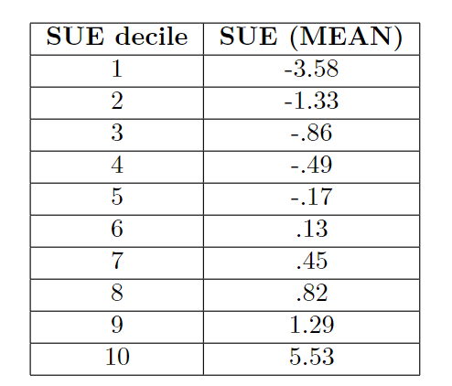

from the table we can see that the top5 and bottom 5 portfolio each have negative and positive SUE, and portfolio 10 is significantly posses higher SUE compared with others.

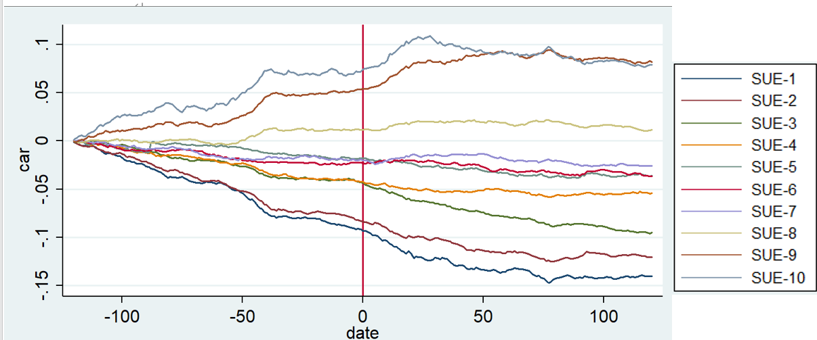

In figure 1, the estimated post-earnings-announcement abnormal returns vary monotonically with the SUE deciles significantly. A long position in portfolio 10, combined with a short position in portfolio 1, yields an estimated abnormal return of 7.3% over 120 trading days after the earning announcement. The issue we now address is whether this estimated abnormal return reflects an incomplete adjustment for risk or a delayed price response.

This study examines the cumulative abnormal returns in Chinese stock markets around the announcement date. Through the back test of the time series model, we take statistics on the semi-annual return and semi-annual statement announcements from 2015 to 2022. At the same time, we use SUE to group stocks, and use the average return to calculate the abnormal return of the portfolio. In our forecasting, we find that earnings surprises highly predict abnormal stock returns following earnings announcements. The top two portfolios with good return statements both exhibit returns in excess of 5%. The results of the study show that there is a significant delay in the reaction of the Chinese market to earnings news. From the figure, we can see that only the first three groups of investment portfolios have positive excess returns, and the rest of the investment portfolios show obvious negative cumulative abnormal returns, resulting in greater drift, which may indicate that in China's stock market, investment Participants are more sensitive to negative statement announcements.

**Limitation**

This study is partly imprecise in the demonstration of PEAD. First of all, this study uses the simple return rate of individual stocks minus the market rate of return when calculating abnormal returns, ignoring the influence of individual stock risks in the return rate. In order to avoid this error, the abnormal return rate of individual stocks can be applied to the three-factor model or the five-factor model. factor model for regression. This error will make the abnormal return rate of high-risk stocks overestimated, making the cumulative abnormal return rate fluctuate greatly. Secondly, this study directly uses the historical return panel, and does not make predictions under unknown announcements, that is, the results of this study only point out the existence of PEAD anomalies, but cannot be applied as a strategy.